**Project Design Phase-II**

**Data Flow Diagram & User Stories**

|  |  |
| --- | --- |
| Date | 27 October 2022 |
| Team ID | PNT2022TMID12047 |
| Project Name | Car Resale value Prediction |
| Maximum Marks | 4 Marks |

**Data Flow Diagrams:**

A Data Flow Diagram (DFD) is a traditional visual representation of the information flows within a system. A neat and clear DFD can depict the right amount of the system requirement graphically. It shows how data enters and leaves the system, what changes the information, and where data is stored.

|  |
| --- |
| DFD Level 0 |

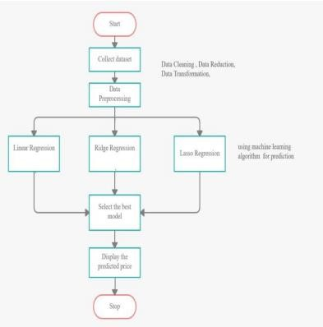**Car Resale Value Prediction**

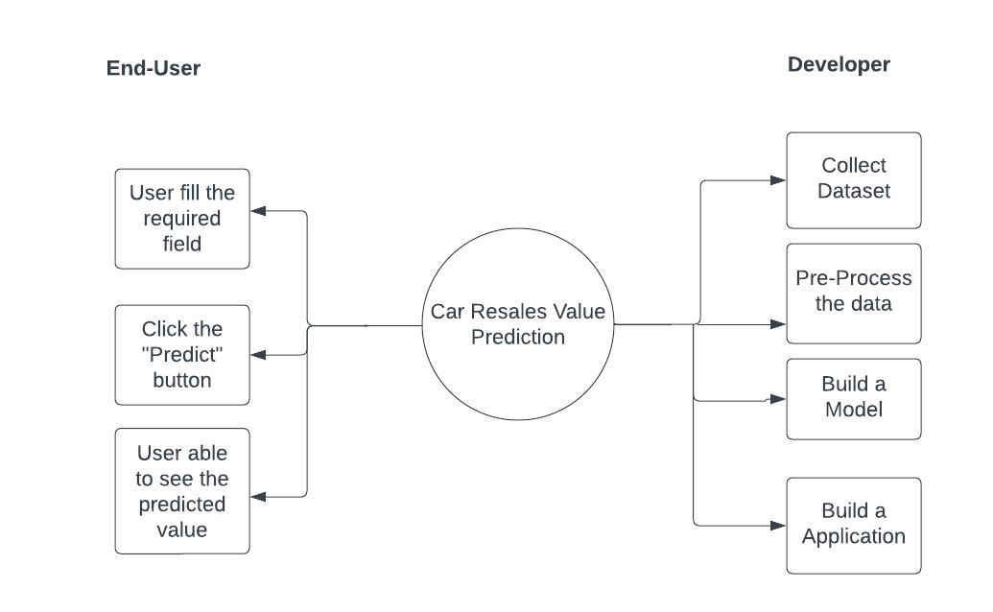

**User Stories**

Use the below template to list all the user stories for the product.

|  |  |  |  |  |  |  |
| --- | --- | --- | --- | --- | --- | --- |
| **User Type** | **Functional**  **Requirement (Epic)** | **User**  **Story**  **Number** | **User Story / Task** | **Acceptance criteria** | **Priority** | **Release** |
| Customer (WebUser) | Fill the required field in the user interface | USN-1 | As a user,I will fill the field with the help text  and drop down menu’s | I can fill the required information in the UI itself | High | Sprint-1 |
|  | After fill all the required fields,User will click the ‘predict’ button. | USN-2 | As a user, I will click ‘Predict’ button to see the value prediction of the used car’s | I can receive value of used car’s prize in the UI | High | Sprint-1 |
|  | User can able to see the multiple time of used car’s prize. | USN-3 | As a user, I can able to reset the previously entered information in the UI. | I can able to reset the fields for new information | Low | Sprint-2 |